**ACCOUNTS & FINANCE**

**MANUAL**

2017-18

(Version 1.1)



For private circulation only

To be circulated strictly with the permission of Management committee

Table of Contents

1. Introduction – Business Overview 4

2. Process –Overview 5

Process –Overview (To be) 5

3. As Is and To Be Process Overview 6

3.1 Daily Bank Reconcilliation. 6

3.1.1 As-Is Process Description 6

3.1.2 As-Is Process Flow 7

3.1.3 To Be Process Description (Accounts Receivable – Billing and Credit Control) 7

3.1.4 To Be Process Flow 7

3.2 Accounts Payable 8

3.2.1 As-Is Process Description 8

3.2.2 As-Is Process Flow 8

3.2.2.1 Purchases………………………………………………………………………………………………………….9

3.2.2.2 Purchase orders………………………………………………………………………………………………..9

3.2.2.3 Goods & Receipt notes………………………………………………………………………………………9

3.2.2.4 Receipt of Supplier bills…………………………………………………………………………………….9

3.2.2.5 Advances to suppliers/contractors………………………………………………………………….10

3.2.2.6 Recurring Payments………………………………………………………………………………………..10

3.2.2.7 Statutory payments…………………………………………………………………………………………10

3.2.2.8 Tally software feature in purchases…………………………………………………………………11

3.2.3 To Be Process Description (Purchase accounting & Payments, Bank & Cash Flow Management)………………………………………………………………………………………………………………12

3.2.4 To Be Process Flow………………………………………………………………………………………....12

3.3 Book Closure Activity……………………………………………………………………………………….13

3.3.1 As-Is Process Description…………………………………………………………………………………………………………………..13

3.3.2 As-Is Process Flow……………………………………………………………………………………………13

3.3.3 To Be Process Description……………………………………………………………………………….13

3.3.4 To Be Process Flow………………………………………………………………………………………….14

3.4 Management Reporting…………………………………………………………………………………..14

3.4.1 As-Is Process Description………………………………………………………………………………..14

3.4.2 As-Is Process Flow…………………………………………………………………………………………..14

3.4.3 To Be Process Description 15

3.4.4 To Be Process flow 16

3.5 Responsibility Matrix 17

# Introduction – Business Overview

Campus Students Communities (CSC) is a leading enterprise with 15 years of domain expertise in an exclusive concept of company owned and managed student housing communities to cater high quality experience. This unique concept is important in maintaining more varied and balanced student housing industry and contributed to price stability and affordability. Commitment to expansion, integrity & excellence are the 3 pillars of the enterprise. Management team aims at consistently improvising services with ability to direct individual accomplishments towards organizational objectives. They deliver tailored solutions that allow institutions to provide quality accommodations created specifically for the unique demographic of each campus. By blending their grassroots expertise with a fierce commitment to quality, they provide non-parallel service and value to students, parents and universities, while consistently outperforming their peers of student housing industry.

With a mission to stay focused, CSC excel in delivering best class experience by developing sustainable relationships with institutions leading to their goal achievement of recruitment and retention.

# Process –Overview

The Department Accounts primarily handles the Accounting activities of the Funds &Payments Received, Payables and Financial Book Closure activities supported by Internal & Statutory Auditors. The Primary functions can be divided into following

1. Daily Funds Reconciliation – Daily Analysis of Funds realised in Bank and Accounting
2. Accounts Payables - Processing of Purchase Bills.
3. Book Closing Activities – Supporting in Book Closure Activities in guidance with Internal and Statutory Auditors.

**In Scope** : Accounts Payables, Receivables and Book Closure Activity

**Out of Scope** : Treasury Activities

# Process –Overview (To be)

To be process is proposed with end to end finance and accounts activities under following Categories.

Accounts Receivable

* Billing and Credit Control

Accounts Payable (including Treasury)

* Purchase accounting and Payments.
* Bank & cash flow management.

Book Closure (Financial Accounting)

* Inventory Management and Cost Control
* Compliances, Preparation of Financial statements
* Taxation, Statutory compliance &Handling tax issues
* Financial Statements.
* Payroll System.
* Internal and Statutory Audit Support.

Management Reporting

* Budgeting and Budgetary control
* Working Capital Management

# As Is and To Be Process Overview

## Daily Bank Reconciliation.

### As-Is Process Description

Daily Bank Reconciliation is activity to account receivables in the books of accounts for all money deposited from Students.

This activity starts with a query from BD team for confirming the Advance received which would lead into finishing admission formalities or Every day Bank Statement is analyzed for all receipts in the bank account.

Further these amounts are accounted in books of account by creating a Debtor account in financial books (Tally is the software used). Further it is treated as refundable deposit or advance fees.

Advance fees would be amortized on a monthly basis as per the utilization.

**Inputs:** Bank Statement, Admission form from BD Team

**Critical Decision making Points:** Amount realized in Bank

**Exceptions: As per management discretion.**

**Outputs:** Confirmed Admission, Money realized in Bank, Debtors Accounting.

### As-Is Process Flow

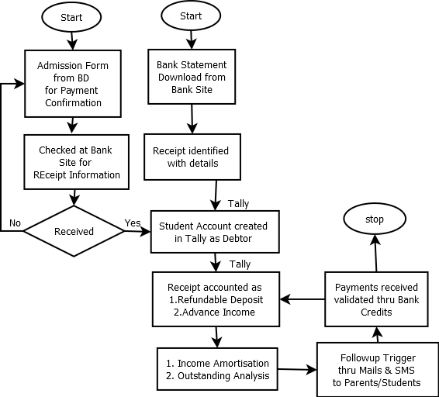

### To Be Process Description (Accounts Receivable – Billing and Credit Control)

Key changes in To be process would include Billing raised to the students and services rendered by CSC. This would ensure the total revenue generated by the Company.

Also as a control CSC to maintain exclusive Bank account for Accounts receivable and Non-Payment activities to be performed in this Bank. Also on a daily basis Account sweep to be ensured that all funds received is transferred to Common Bank account for better control.

### To Be Process Flow



## Accounts Payable

### As-Is Process Description

This activity is to ensure that all purchases and services obtained are verified with PO, Bills approved as per authority and Payment on time to the creditors.

AP process is initiated from the bills received from various teams matched with the Approved PO, verified and validated for correctness, Accounted in the books of Accounts and payment as per due date

**Inputs:** Bills from various departments, Purchase Order, Goods Receipt& Advance request.

**Critical Decision making Points:** Funds availability in Banks, Goods Receipt.

**Exceptions: Cash Purchases.**

**Outputs:** Payment on Time.

### As-Is Process Flow

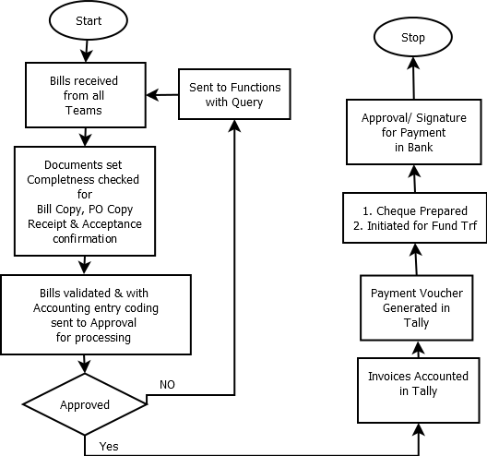

**3.2.2.1 Purchases**

For regulating the payment of suppliers’ claims, purchase accounting section will receive the following documents

• Purchase orders (POS)

• Goods receipt notes (GRNS)

• Bills of the suppliers.

All the three sets of documents are controlled through serial numbers given to them. The control serial numbers are given for P.Os and GRNS in the indenting department and the stores respectively whereas in the case of suppliers’ bill the same is given in the purchase accounting section. GRNS are not raised for supply of capital equipment and purchases made by administration department. In these cases, certificates of receipt / completion will be recorded and sent to purchase accounting section by the department concerned.

**3.2.2.2 Purchase Order**

• Purchase orders will be received from the O&M and F&B department.

• On receipt, these will be checked for the number of financial concurrence record there on and then entered in the register of purchase orders.

• Purchase orders and their amendments will be filled vendor wise.

**3.2.2.3 Goods Receipts Notes**

• GRNs will be received through the stores ledger keeper these will be filled vendor wise.

**3.2.2.4 Receipt of Supplier’s Bills**

* The Other departments in the organization send their bills direct to the purchase accounting section. In case of progress and final payment, the bills will be supported by supplier’s copy of GRN.
* A control register of incoming bills will be maintained in the purchase accounting section to watch their disposal. On receipt, the bills will be entered in the register and the serial no after the register and the dates of receipt will be noted on them. Disposal of the bills also will be noted in the register as soon as these are passed for payment of returns to the supplier for rectification/clarification, etc. no bill will be kept pending for more than a week.
* A weekly report of outstanding bills will be submitted by the purchase accounting section to the head of the finance and account department along with reasons for daily in their disposal.

**3.2.2.5 Advances to Suppliers / Contractors**

Generally NO advances will be given except in special circumstances or proprietary nature of supplies or contracts.

Advances to the suppliers / contractors are of the following kinds:

* 10% of total value of supply or contract as Mobilization Advance payable along with the placement of order against submission of equivalent amount of bank guarantee or as agreed upon.
* 90 to 100 percent payments against proof of dispatch of supplies and certification form concerned department on receipt of such service or material in good condition.
* Where advance payments are provided in the purchase/work orders, suppliers’ bills will be checked with the terms thereof. In case the suppliers are required to furnish bank guarantee/ indemnity bond to obtain the advance, purchase section will be forwarded to cash section along with the payment vouchers.
* All advance payments to suppliers including those made for materials received subject to acceptance, will be debited to appropriate account code -‘’Advances to contractors/ suppliers’’.
* The advances paid will be noted on the relevant purchase orders and will be adjusted as per the agreed terms. Where an advance payment has been made against proof of dispatch, adjustment will be on receipt of material. The adjustments also will be noted on the purchase order.

**3.2.2.6 Recurring payments**

* The recurring payments in the company include Wifi bills, electricity bills, water bills, maintenance bills, food related items bills, gas bills etc.
* These bills which are paid daily/monthly basis are called recurring bills.
* So procedure for payments is started by department submitting the bills before 10-15 days of due date. These bills need to be signed by the departmental head as well as maintenance head. Then this needs final approval of the Management Committee. After approving, it will be sent to accounts department for making payment in process.

**3.2.2.7 Statutory payments**

* The Statutory Payments report will help to verify whether Direct and Indirect Taxes (including Provident Fund & Employee State Insurance) has been remitted to the required authorities as applicable.
* This report also shows whether details of the tax payable, tax paid and balance if any along with Payment Status such as Paid on time, Paid Late, Partially paid, Due etc. To view the Statutory Payments report, Go to **Gateway of Tally > Audit & Compliance > Audit & Analysis > Statutory Payments**

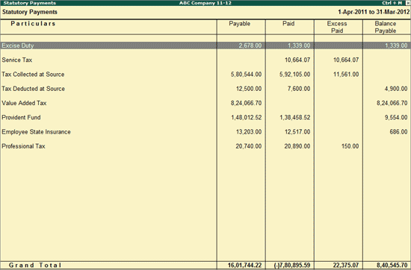

**Softwares used**: The auditors use tally software to determine the details of tax payment and also payments status as shown in the above figure: Every detail is maintained in tally software like vendor registration, data collection of each vendor and purchase orders.

With Tally's accounting process, we can accurately plan purchases, manage working capital and improve cash flow. It allows us to keep a check on expenditures, handle exceptions in business processes and manage our financials in a better fashion.

**3.2.3.8 Regarding tally software feature in purchases**

Purchases form a significant component of total expenditure. Therefore, it becomes essential for us to track purchases from one end to the other and plan manufacturing cycle accordingly. Tally enables us to instantly check the status of stock available, know overdue orders and pending incomings that help us manage inventory requirements.   
  
The key features are:   
• Purchase Invoicing  
• Purchase Orders Processing  
• Reorder Levels  
• Item Batch-Wise Details  
• Additional Cost of Purchase  
• Purchase Registers

### To Be Process Description (Purchase accounting &Payments, Bank& Cash Flow Management)

Key Changes to be made

* Invoice Accounting and Payment initiation based on the due date,
* Payment voucher with Intimation to Vendors and departments.
* Fund Management check and Fund transfer activity updated as a part of flow.

### To Be Process Flow

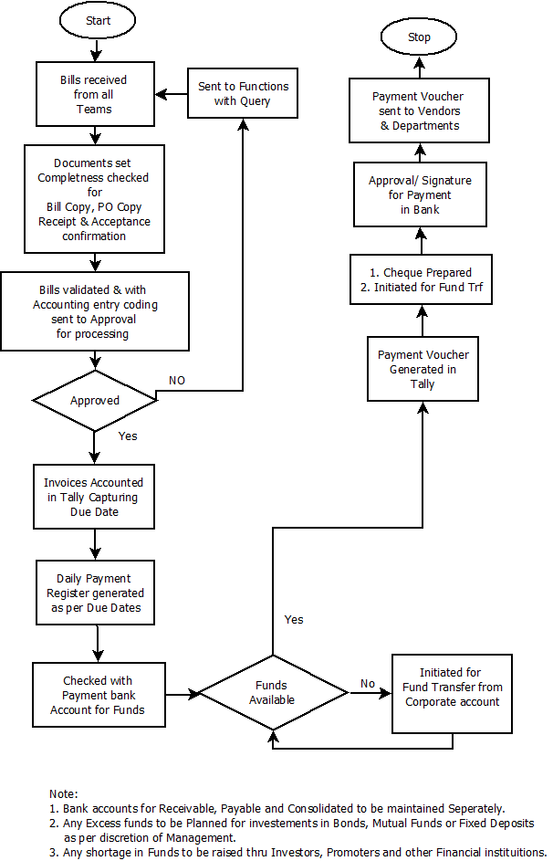

## Book Closure Activity

### As-Is Process Description

This is the activity of ensuring that all entries are passed in the system for Book closure. Some of these entries are Bank Reconciliation, Provision for expenses, Fixed Asset Depreciation entry, Amortization of Income. Schedules to Accounts, Statutory liability entries and other book closure related entries.

**Inputs: Inputs** / Approval from Internal Auditors, Book closure calendar.

**Critical Decision making Points:** Approval from Statutory and Internal Auditors

**Outputs: Book** Closure.

### As-Is Process Flow

Not Applicable

### To Be Process Description

Primary activities for Book Closing can be classified.

* Inventory Management and Cost Control
* Accounting Compliances, Preparation of Financial statements
* Taxation, Statutory compliance &Handling tax issues
* Financial Statements.
* Payroll System.
* Internal and Statutory Audit Support.

To ensure smooth monthly book closure activities, Standards Checklist needs to be created indicating activities which needs to be done Daily/Monthly/Yearly with cut off. (Checklist to be derived in discussion with Internal Auditor)

Some of the book closure activities are

1. Bank reconciliation entries for all operating entries
   1. Fund Transfer
   2. Sweep
   3. Bank Memo
   4. Bank charges
   5. Interest
2. Petty Cash entries.
3. Provision for expenses/Income
4. Depreciation and Amortization
5. Schedule to Accounts
6. Expense Analysis and rectification.
7. Statutory liability and Payout entries (TDS,GST,ST, PF,ESI,PT…)
8. Pay roll entries
9. Prepaid expenses
10. Others
11. Cash flow statements
12. Trial Balance analysis
13. Balance sheet and P&L Analysis.

### To Be Process Flow

Activities are based on the Checklist for Pre-Book Closure and Post Book Closure.

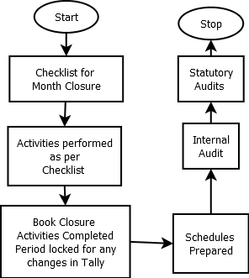

## Management Reporting

### As-Is Process Description

Currently few of the activities are supported by Individual departments.

### As-Is Process Flow

Not Applicable.

### To Be Process Description

The Primary responsibility of Management reporting is to create the Annual Budget for CSC and subsequently maintain and control the same by analysis of Actuals with variance analysis.

Also, this activity would enable to manage the working capital and also do regular Management review with Top Management and board.

Currently Management reporting would be delivering activities as following

* Budgeting and Budgetary control
* Working Capital Management

### To Be Process flow

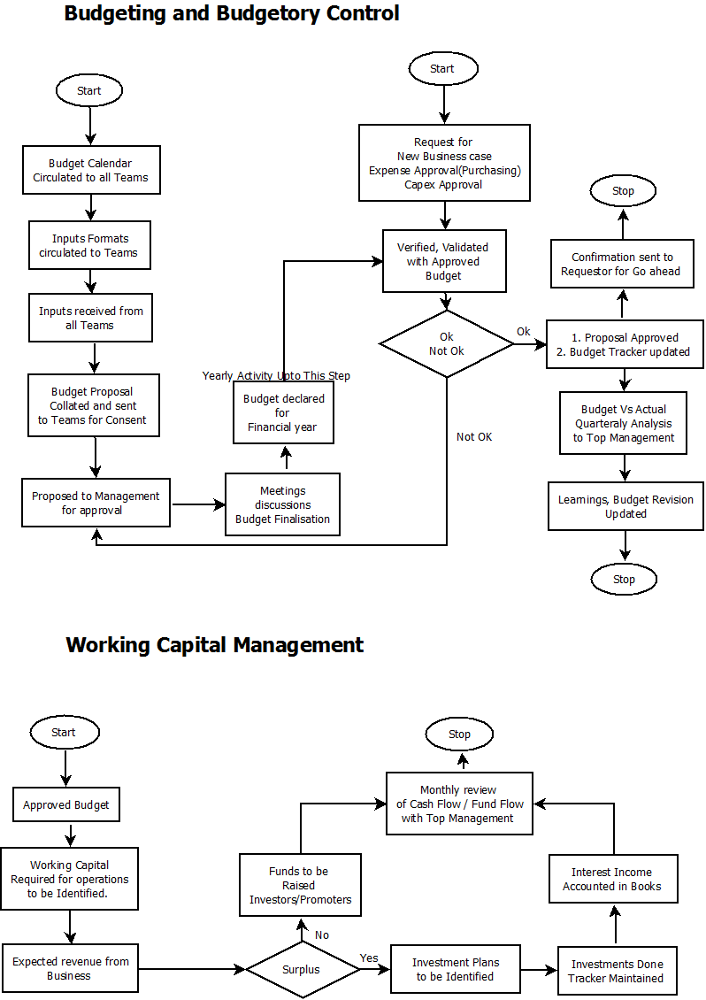

## Responsibility Matrix

| **Responsibility Matrix – Process** | | | |
| --- | --- | --- | --- |
| **#** | **Task/Function** | **Standard** | **Exception** |
| 1 | Accounts Receivable – Admission Support | AP/AR Executive | AR Lead |
| 2 | Account Receivable Maintenance | AR lead | Finance Head |
| 3 | Accounts Payable (Creditors, employees, Statutory and Fund Transfers) | AP/AR Executive | AP Head |
| 4 | Bank Operations | AP Lead | Finance Head |
| 5 | Book Closure (GL) | Finance Head | CFO |
| 6 | Management Reporting | MR Head | CFO |
|  |  |  |  |